

Title:
Cat & Dog Images classification using CNN
Submitted by:
Abdul Qadir
Roll No .
052-SP23-22043
Submitted to:
Mam Tahira Kanwal
Course / Department:
Artificial Intelligence / CS
Date of Submission:
17th^{nd} June 2026
Institution:
Iqra University, Chak Shehzad Campus

Cat and Dog Image Classification Using CNN

Introduction
This project uses a Convolutional Neural Network (CNN) to classify images of cats and dogs. The model learns visual features such as shape, face structure, ears, eyes, and body patterns from images. The purpose of this project is to build a simple deep learning model that can predict whether the given image is a cat or a dog.

Objectives
The main objective of this project is to build a CNN model for cat and dog image classification.
The project aims to train the model using a small Kaggle image dataset.
The final goal is to test the model on images and show the predicted class with confidence score.

Dataset Description
The dataset used in this project contains images of cats and dogs. It has two main classes: Cat and Dog. The images are loaded from folders, resized to a fixed size, and used for training and validation of the CNN model.

Project Architecture
The system takes a cat or dog image as input.
The image is resized, normalized, and passed into the CNN model.
The CNN model extracts image features and predicts the final class as Cat or Dog.

Libraries Used
TensorFlow/Keras: Used to build, train, and test the CNN model.
NumPy: Used for numerical operations and prediction handling.
Matplotlib: Used to display images, graphs, and prediction results.
OS: Used to access dataset folders and paths.
Zipfile: Used to extract the Kaggle dataset ZIP file.

Import Libraries
In this cell, all required libraries are imported for the Cat and Dog CNN classification project.
These libraries are used to extract the dataset, load images, build the CNN model, train it, and display results.
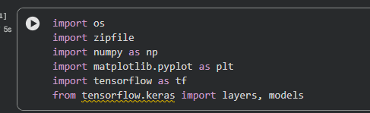

Extract Dataset
In this cell, the uploaded Kaggle dataset file archive.zip is extracted in Google Colab.
After extraction, the cat and dog image folders become available for loading and training the CNN model.
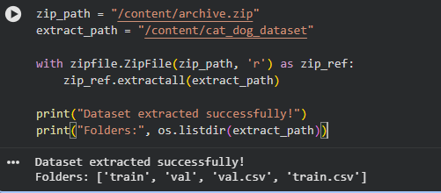
Load Dataset
In this cell, the main dataset folder is found automatically and cat/dog images are loaded.
The dataset is divided into training and validation sets so the CNN model can learn and check its performance.
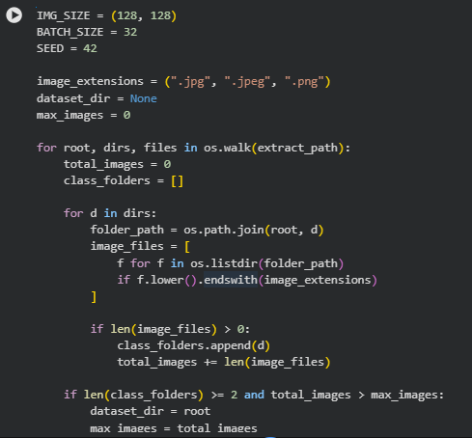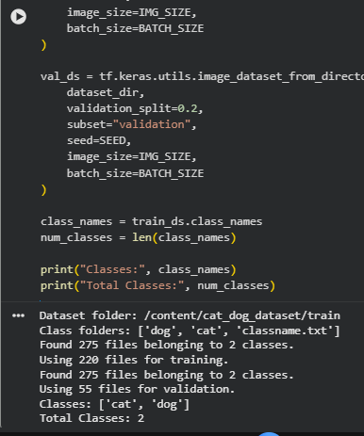

Show Sample Cat and Dog Images
This cell displays sample images from the training dataset.
It helps confirm that cat and dog images are loaded correctly with their labels before training the CNN model.
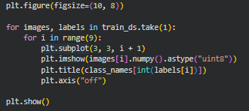
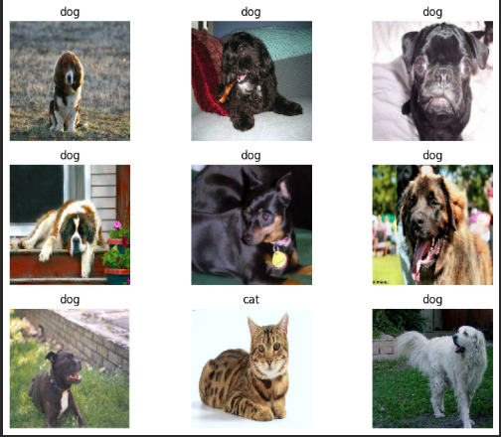

Build CNN Model
This cell builds a CNN model for cat and dog image classification.
Convolution layers extract image features, pooling layers reduce size, and dense layers predict the final class.
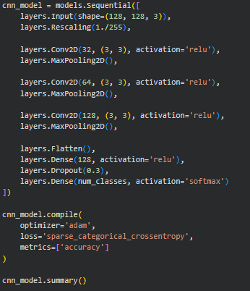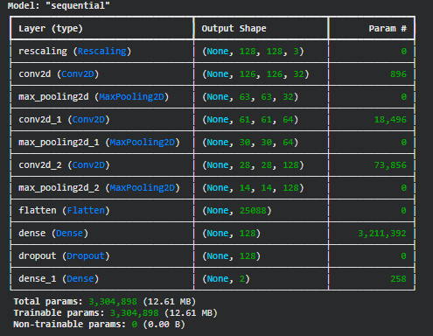

Train CNN Model
This cell trains the CNN model using cat and dog images from the training dataset.
During training, the model learns visual patterns and checks its performance using validation data.
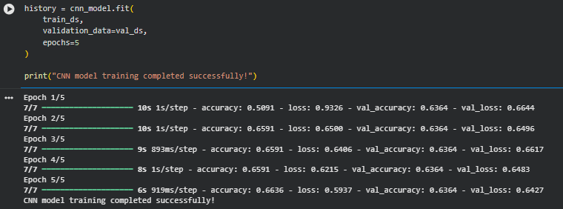

Show CNN Prediction Results on Images
This cell tests the trained CNN model on cat and dog images.
It shows each image with actual label, predicted label, and confidence score to prove that the CNN model is working.
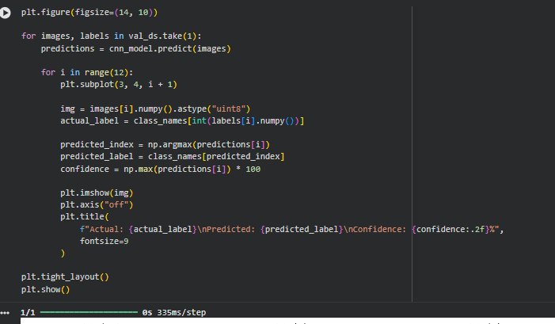

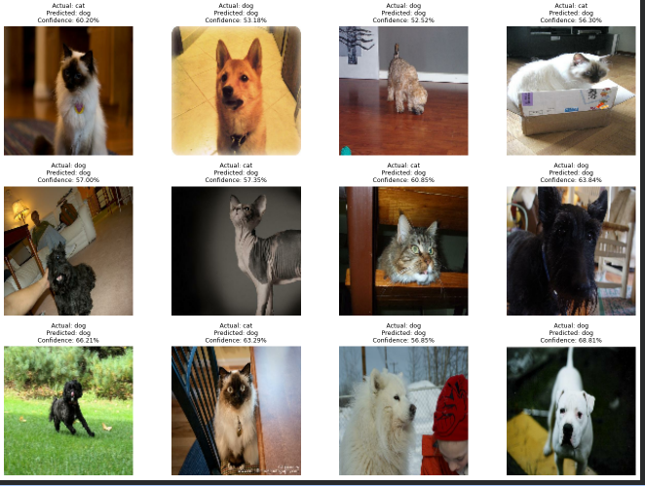
Conclusion
This project successfully developed a CNN-based Cat and Dog image classification system. The model was trained using a small Kaggle dataset and learned visual features from cat and dog images.
The trained CNN model predicted the class of validation images and displayed the actual label, predicted label, and confidence score. The model was also evaluated using validation accuracy and validation loss.
Overall, this project shows that CNN can be used effectively for simple image classification tasks.

